Step 1:open windows and type the command as nikto -h [www.zoho.com](http://www.zoho.com) -tuning x

Step 2: press enter 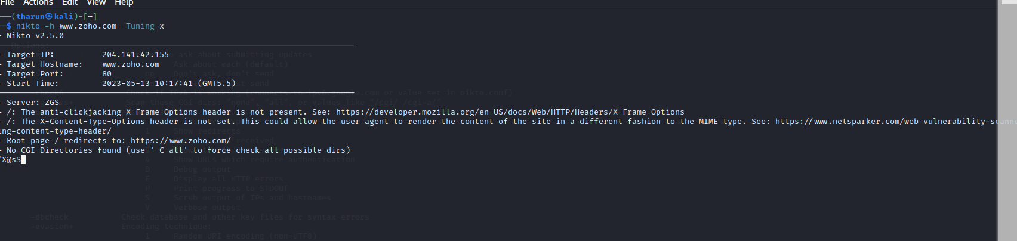

Step 3:type the command as nikto -h [www.certifiedhacker.com](http://www.certifiedhacker.com) -Cgidirs all

Step 4: it will show output as given below

